

Vietnamese Study System for Japanese

DETAIL DESIGN DOCUMENT

Data Design

**Project Code: Veazy**

**Document Code: Veazy_Data Design_v1.0_EN**

**Ha Noi, 03/08/2016**

Record of change

*A - Added M - Modified D – Deleted

|  |  |  |  |  |
| --- | --- | --- | --- | --- |
| **Effective Date** | **Changed Items** | **A* M, D** | **Change Description** | **New Version** |
| 03/08/2016 | Add new | A |  | v1.0 |
|  |  |  |  |  |
|  |  |  |  |  |
|  |  |  |  |  |
|  |  |  |  |  |
|  |  |  |  |  |
|  |  |  |  |  |
|  |  |  |  |  |
|  |  |  |  |  |
|  |  |  |  |  |

SIGNATURE PAGE

**ORIGINATOR:** Dao Thanh Tung 03/08/2016

Developer

**REVIEWERS:**

**APPROVAL:** Nguyen Van Sang

Supervisor

TABLE OF CONTENTS

1 Introduction 5

1.1 Purpose 5

1.2 Definitions, Acronyms and Abbreviations 5

1.3 References 5

1.4 Overview 5

2 Database 6

2.1 ERDs 6

2.2 Table Database 7

2.2.1 Table diagram 7

2.2.2 User table 8

2.2.3 course table 9

2.2.4 Question table 9

2.2.5 Answer table 10

2.2.6 QuestionModel_content table 11

2.2.7 Exam table 11

2.2.8 ExamAnswer table 11

2.2.9 lesson table 12

2.2.10 lessonversion table 12

2.2.11 report table 13

2.2.12 javi table 14

2.2.13 vija table 14

2.2.14 example table 14

3 Appendix 15

3.1 Data format symbol 15

# Introduction

## Purpose

Vietnamese Study System for Japanese data design document describes the structure of database and the structure of file system including internal files structure as well as interface files structure.

## Definitions, Acronyms and Abbreviations

|  |  |  |
| --- | --- | --- |
| Abbreviations | Description | Comment |
| P/F | Primary/ Foreign key | Use to indicate that a field is a primary or foreign key in table |
| NOT | the attribute can’t be null | Set value “not null” for attribute in table |
| U | the attribute is unique | Set value “unique” for attribute in table |
| CRUD | Create, read, update, delete |  |

## References

List the entire reference document such as: other document of the system, or the technical article.

|  |  |
| --- | --- |
| Document Number | Title |
|  |  |
|  |  |

## Overview

General overview of the detail design such as what is the structure of the document: N/A

# Database

## ERDs

Entity relationship diagrams

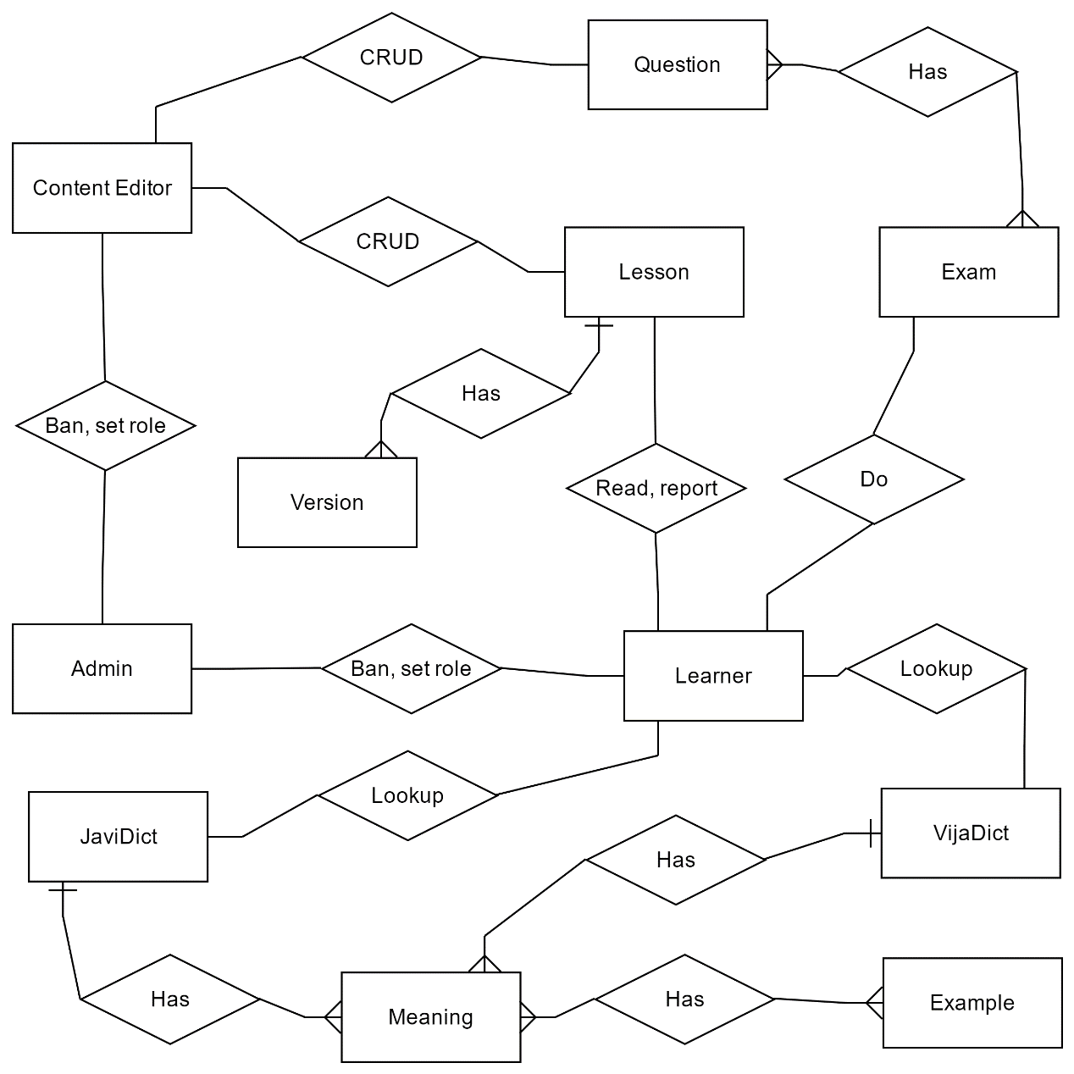

**Figure 1: Entity relationship diagrams**

|  |  |  |
| --- | --- | --- |
| **No** | **Entity** | **Description** |
| 1 | Admin | System administrator |
| 2 | Learner | The end-user who learn on the website |
| 3 | Content Editor | The user who create, update lesson content and questions. |
| 4 | Question | Question for the exam |
| 5 | Lesson | The lesson |
| 6 | Version | The version of lesson |
| 7 | Exam | Examination for the user |
| 8 | VijaDict | Vietnamese-Japanese Dictionary |
| 9 | JaviDict | Japanese-Vietnamese Dictionary |
| 10 | Meaning | The meaning of word in dictionary |
| 11 | Example | Example for each meaning |

|  |  |  |
| --- | --- | --- |
| **No** | **Table Name** | **Description** |
|  | User | Store user information |
|  | course | Store course information |
|  | Question | Store question information |
|  | Answer | Store answer of question |
|  | QuestionModel_content | Store child question of group question |
|  | Exam | Store all exam of user. |
|  | ExamAnswer | Store exam answer |
|  | lesson | Store lesson information |
|  | lessonversion | Store the version of lesson |
|  | report | Store user report |
|  | javi | Store Japanese Vietnamese dictionary |
|  | vija | Store Vietnamese Japanese dictionary |
|  | example | Store example for word meaning |

## Table Database

### Table diagram

Figure 2: Table diagram

n

List of tables and brief description

### User table

|  |  |  |  |  |  |  |  |  |
| --- | --- | --- | --- | --- | --- | --- | --- | --- |
| No | Field Name | Type | Max  Length | Null | Unique | P/F Key | Default | Description |
| 1 | id | integer |  | NOT |  | P |  | Auto increase |
| 2 | createdate | bigint |  |  |  |  |  |  |
| 3 | deletedate | bigint |  |  |  |  |  |  |
| 4 | deleteflag | boolean |  | NOT |  |  | FALSE |  |
| 5 | updatedate | bigint |  |  |  |  |  |  |
| 6 | address | character | 30 |  |  |  |  |  |
| 7 | bio | character |  |  |  |  |  | about me |
| 8 | dob | bigint |  |  |  |  |  | date of birth |
| 9 | email | character | 254 |  | U |  |  |  |
| 10 | password | character(32) |  | NOT |  |  |  | encrypted password |
| 11 | firstname | character |  |  |  |  |  |  |
| 12 | hobby | character |  |  |  |  |  |  |
| 13 | isbanned | boolean |  | NOT |  |  | FALSE |  |
| 14 | joindate | bigint |  | NOT |  |  |  |  |
| 15 | lastname | character | 30 |  |  |  |  |  |
| 16 | quote | character |  |  |  |  |  |  |
| 17 | role | integer |  | NOT |  |  | 3 |  |
| 18 | username | character | 30 | NOT | U |  |  |  |
| 19 | website | character |  | NOT |  |  |  |  |

### course table

|  |  |  |  |  |  |  |  |  |
| --- | --- | --- | --- | --- | --- | --- | --- | --- |
| No | Field Name | Type | Max  Length | Null | Unique | P/F Key | Default | Description |
| 1 | id | integer |  | NOT |  | P |  |  |
| 2 | des | character | 255 |  |  |  |  | description |
| 3 | name | character | 50 | NOT | U |  |  |  |

### Question table

|  |  |  |  |  |  |  |  |
| --- | --- | --- | --- | --- | --- | --- | --- |
| No | Field Name | Type | Null | Unique | P/F Key | Default | Description |
| 1 | id | integer | NOT |  | P |  | Auto increase |
| 2 | createdate | bigint |  |  |  |  |  |
| 3 | deletedate | bigint |  |  |  |  |  |
| 4 | deleteflag | boolean | NOT |  |  | FALSE |  |
| 5 | updatedate | bigint |  |  |  |  |  |
| 6 | attachment | character |  |  |  |  |  |
| 7 | courseid | integer | NOT |  |  |  |  |
| 8 | creatorid | integer | NOT |  |  |  |  |
| 9 | numberofquestion | integer | NOT |  |  | 1 |  |
| 10 | question | character | NOT |  |  |  |  |
| 11 | questionanswertype | integer | NOT |  |  | 1 |  |
| 12 | questioncode | integer | NOT | U |  |  |  |
| 13 | questionskill | integer | NOT |  |  | 1 |  |
| 14 | questiontype | integer | NOT |  |  | 1 |  |
| 15 | state | integer | NOT |  |  | 1 |  |

### Answer table

|  |  |  |  |  |  |  |  |
| --- | --- | --- | --- | --- | --- | --- | --- |
| No | Field Name | Type | Null | Unique | P/F Key | Default | Description |
|  | id | integer | NOT |  | P |  | Auto increase |
|  | createdate | bigint |  |  |  |  |  |
|  | deletedate | bigint |  |  |  |  |  |
|  | deleteflag | boolean | NOT |  |  |  |  |
|  | updatedate | bigint |  |  |  |  |  |
|  | answer | character | NOT |  |  |  |  |
|  | isright | boolean | NOT |  |  |  |  |
|  | questionmodel_id | integer | NOT |  | F |  |  |

### QuestionModel_content table

|  |  |  |  |  |  |  |  |
| --- | --- | --- | --- | --- | --- | --- | --- |
| No | Field Name | Type | Null | Unique | P/F Key | Default | Description |
| 1 | QuestionModel_id | integer | NOT |  | PF |  |  |
| 2 | content | integer |  |  |  |  |  |

### Exam table

|  |  |  |  |  |  |  |  |
| --- | --- | --- | --- | --- | --- | --- | --- |
| No | Field Name | Type | Null | Unique | P/F Key | Default | Description |
| 1 | id | integer |  |  | P |  | Auto increase |
| 2 | createdate | bigint, |  |  |  |  |  |
| 3 | deletedate | bigint, |  |  |  |  |  |
| 4 | deleteflag | boolean | NOT |  |  | FALSE |  |
| 5 | updatedate | bigint, |  |  |  |  |  |
| 6 | courseid | integer | NOT |  |  |  |  |
| 7 | result | real | NOT |  |  | 0.0 |  |
| 8 | userid | integer | NOT |  |  |  |  |

### ExamAnswer table

|  |  |  |  |  |  |  |  |
| --- | --- | --- | --- | --- | --- | --- | --- |
| No | Field Name | Type | Null | Unique | P/F Key | Default | Description |
| 1 | id | integer | NOT |  | P |  | Auto increase |
| 2 | createdate | bigint |  |  |  |  |  |
| 3 | deletedate | bigint |  |  |  |  |  |
| 4 | deleteflag | boolean | NOT |  |  | FALSE |  |
| 5 | updatedate | bigint |  |  |  |  |  |
| 6 | questionid | integer | NOT |  |  |  |  |
| 7 | useranswer | character | NOT |  |  |  |  |
| 8 | exammodel_id | integer | NOT |  | F |  |  |

### lesson table

|  |  |  |  |  |  |  |  |
| --- | --- | --- | --- | --- | --- | --- | --- |
| No | Field Name | Type | Null | Unique | P/F Key | Default | Description |
| 1 | id | integer | NOT |  | P |  | Auto increase |
| 2 | createdate | bigint |  |  |  |  |  |
| 3 | deletedate | bigint |  |  |  |  |  |
| 4 | deleteflag | boolean | NOT |  |  | FALSE |  |
| 5 | updatedate | bigint |  |  |  |  |  |
| 6 | courseid | integer | NOT |  |  |  |  |
| 7 | versionid | integer |  |  |  |  |  |

### lessonversion table

|  |  |  |  |  |  |  |  |
| --- | --- | --- | --- | --- | --- | --- | --- |
| No | Field Name | Type | Null | Unique | P/F Key | Default | Description |
| 1 | id | integer | NOT |  | P |  | Auto increase |
| 2 | createdate | bigint |  |  |  |  |  |
| 3 | creatorid | integer | NOT |  |  |  |  |
| 4 | description | text | NOT |  |  |  |  |
| 5 | grammar | text |  |  |  |  |  |
| 6 | lessonid | integer | NOT |  |  |  |  |
| 7 | listening | text |  |  |  |  |  |
| 8 | practice | text |  |  |  |  |  |
| 9 | reading | text |  |  |  |  |  |
| 10 | state | integer | NOT |  |  | 1 |  |
| 11 | title | character | NOT |  |  |  |  |
| 12 | updatedate | bigint |  |  |  |  |  |
| 13 | version | integer | NOT |  |  | 1 |  |
| 14 | vocab | text |  |  |  |  |  |

### report table

|  |  |  |  |  |  |  |  |
| --- | --- | --- | --- | --- | --- | --- | --- |
| No | Field Name | Type | Null | Unique | P/F Key | Default | Description |
| 1 | id | integer | NOT |  | P |  | Auto increase |
| 2 | content | character |  |  |  |  |  |
| 3 | createdate | bigint |  |  |  |  |  |
| 4 | deletedate | bigint |  |  |  |  |  |
| 5 | isdeleted | boolean | NOT |  |  | FALSE |  |
| 6 | lessonid | integer |  |  |  |  |  |
| 7 | questionid | integer |  |  |  |  |  |
| 8 | isread | boolean | NOT |  |  | FALSE |  |
| 9 | receiverid | integer |  |  |  |  |  |
| 10 | senderid | integer |  |  |  |  |  |

### javi table

|  |  |  |  |  |  |  |  |
| --- | --- | --- | --- | --- | --- | --- | --- |
| No | Field Name | Type | Null | Unique | P/F Key | Default | Description |
| 1 | id | integer | NOT |  | P |  | Auto increase |
| 2 | kana | text |  |  |  |  |  |
| 3 | mean | text | NOT |  |  |  | json format |
| 4 | word | text | NOT |  |  |  |  |

### vija table

|  |  |  |  |  |  |  |  |
| --- | --- | --- | --- | --- | --- | --- | --- |
| No | Field Name | Type | Null | Unique | P/F Key | Default | Description |
| 1 | id | integer | NOT |  | P |  | Auto increase |
| 3 | mean | text | NOT |  |  |  | json format |
| 4 | word | text | NOT |  |  |  |  |

### example table

|  |  |  |  |  |  |  |  |
| --- | --- | --- | --- | --- | --- | --- | --- |
| No | Field Name | Type | Null | Unique | P/F Key | Default | Description |
| 1 | id | integer | NOT |  | P |  |  |
| 2 | ja | text | NOT |  |  |  | Japanese sentence |
| 3 | vi | text | NOT |  |  |  | Vietnamese sentence |

# Appendix

## Data format symbol

Following symbols are used to describe format of data field in files as well as in tables.

|  |  |
| --- | --- |
| Symbol | Description |
| # | Digit placeholder. |
| . | Decimal placeholder. |
| , | Thousands separator. |
| : | Time separator. |
| / | Date separator. |
| \ | Treat the next character in the mask string as a literal. This allows you to include the '#', '&', 'A', and '?' characters in the mask. This character is treated as a literal for masking purposes. |
| > | Convert all the characters that follow to uppercase. |
| < | Convert all the characters that follow to lowercase. |
| A | Alphanumeric character placeholder (entry required). |
| A | Alphanumeric character placeholder (entry optional). |
| 9 | Digit placeholder (entry optional). For example: 0 – 9. |
| 0 | Digit placeholder (entry required). For example: 0 – 9. |
| C | Character or space placeholder (entry optional). Valid values for this placeholder are ANSI characters in the following ranges: 32-126 and 128-255. |
| & | Character placeholder (entry required). Valid values for this placeholder are ANSI characters in the following ranges: 32-126 and 128-255. |
| ? | Letter placeholder. For example: a – z or A – Z. |
| Literal | All other symbols are displayed as literals; that is, as themselves. bound in “” like “ABC” |